Child Management System on Salesforce for CRM Charity

Project Management Plan

By

Dolawat Wannapira 572115022

Suradis Sutampang 572115058

Department of Software Engineering

College of Arts, Media and Technology

Chiang Mai University

**Project Advisor**

Dr. Chartchai Doungsa-ard

**Document History**

|  |  |  |  |  |  |  |
| --- | --- | --- | --- | --- | --- | --- |
| Document Name | Version | Status | Date | Viewable | Editable | Responsible |
| Project Plan V 0.1 | - **Add Chapter 1**  - Identification  - Project Overview  - Document Overview  - Acronyms and Definitions | Draft | 04/07/2017 | DO,SU,CC | DO,SU | DO,SU |
| Project Plan V 0.2 | - **Add Chapter 2**  - Software Development Life Cycle  - Software Acquisition Plans  - **Add Chapter 3**  - Project Team Structure  - Monitoring and Controlling Mechanisms | Draft | 10/07/2017 | DO,SU,CC | DO,SU | DO,SU |
| Project Plan V 1.0 | - **Add Chapter 4**  - 4.1 ISO 29110 for Very Small Entity (VSE)  - **Add Chapter 5**  - Schedule  - Milestone  - **Add Chapter 6**  - Software Configuration Management  - Filename Format  - Change Management  - Project Repository  - **Add Chapter 7**  - Risk Management Process  - Risk Identification and Solutions | Released | 27/07/2017 | DO,SU,CC | DO,SU | DO,SU |

DO = DOLAWAT WANNAPIRA

SU = SURADIS SUTAMPANG

CC = DR. CHARTCHAI DOUNGSA-ARD

**Table of content**

**CHAPTER ONE | Overview** 4

1.1 Identification 4

1.2 Project Overview 4

1.2.1 Purpose & Scope 4

1.3 Document Overview 6

1.4 Acronyms and Definitions 6

1.4.1 Acronyms 6

1.4.2 Definitions 7

**CHAPTER TWO | Infrastructure** 8

2.1 Software Development Life Cycle 8

2.2 Software Acquisition Plans 9

2.2.1 Design Tools 9

**CHAPTER THREE | Management Procedures** 10

3.1 Project Team Structure 10

3.2 Monitoring and Controlling Mechanisms 10

3.2.1 Project Meeting 10

**CHAPTER FOUR | Quality Standard** 11

4.1 ISO 29110 for Very Small Entity (VSE) 11

4.1.2 Software Implementation (SI) process 13

**CHAPTER FIVE | Schedule and Milestones** 15

5.1 Schedule 15

5.2 Milestone 17

**CHAPTER SIX | Software Configuration** 21

6.1 Software Configuration Management 21

6.2 Filename Format 21

6.3 Change Management 22

6.4 Project Repository 22

**CHAPTER SEVEN | Risk Management** 23

7.1 Risk Management Process 23

7.2 Risk Identification and Solutions 24

# **CHAPTER ONE | Overview**

## **1.1** **Identification**

The project management of “Child Management System on Salesforce for CRM Charity” is a document for define and display clearly the development plan and quality plan for the “Child Management System on Salesforce for CRM Charity.” This document is intended to be prepared at the beginning of each progress to evaluate schedules, estimations, team structure and development risk. The project plan will help to control, manage, track and alert for difficulties in the development process.

## **1.2 Project Overview**

“Child Management System on Salesforce for CRM Charity” is the web-application that used Salesforce framework for developing. This web-application classified each information and provided user to recording and updating child information and stored the information onSalesforce cloud storage. It aims to help staff in Foundation for children to be able to record, track and manage the information.

### **1.2.1 Purpose & Scope**

The “Child Management System on Salesforce for CRM Charity” is a web-application that focused to help staff in Foundation for children to be able to record, track and manage the information.

The features of “Child Management System on Salesforce for CRM Charity” as shown below:

- Child’s development information management.

- Child's education information management.

- Report development information.

- Child’s information forwarding.

## **1.3 Document Overview**

The purpose of the “Child Management System on Salesforce for CRM Charity” Project Management Plan is to guide project team members during the development of the project.

In this document provides a plan of progress I, progress II, ShowPro progress and final progress. For the progress I, the document consists of Child’s development information management. In the progress II, the document consists of Child's education information management and Report development information. In ShowPro progress, Child’s information forwarding will be added in the document. And the final progress, the overall system and document will be revision and completed.

## **1.4 Acronyms and Definitions**

### **1.4.1 Acronyms**

CMS - Child Managemen System on Salesforce for CRM Charity

SRS - Software Requirement Specification

SDD - Software Design Document

OS - Operating System

PM - Project Management

SI - Software Implementation

VSE - Very Small Entity

### **1.4.2 Definitions**

|  |  |
| --- | --- |
| **Name** | **Description** |
| Acceptance test | Test activities. For sample, checks to verify that the system (or product, solution) has the right quality for deployment or usage. Often acceptance test is done by the customer. |
| Plan | A documented series of tasks requires meeting an objective, typically including the associated schedule, budget, resources, organizational description and work breakdown structure. |
| Project Management | The application of knowledge, skills, tools, and techniques to project activities for meeting or exceed stakeholder needs and expectations from a project. |
| Project Plan | A formal approved document used to guide both project execution and project control. The primary uses of the project plan are to document planning assumptions and decision, to facilitate communication among stakeholders, and to document approved scope, cost, and schedule baseline. |
| Risk | An uncertain event or condition that, if it occurs, has a positive or negative effect on the project’s objectives. It is a function of the probability of occurrence of a given threat’s occurrence. |
| Risk Management | The systematic application of management policies, procedures, and practices to the tasks of identifying, analyzing, evaluating, treating and monitoring risk. |
| Traceability | The ability to trace the history, application or location of an item or activity, or work products or activities, by means of recorded identification. The establishment and maintenance of relationships  between such items. Horizontal traceability describes the relationship between work products of the same  type (e.g., customer requirements). Vertical traceability describes the relationship between work products which build upon each other or are derived from each other (e.g., from customer requirements to qualification test cases). Bidirectional traceability allows to directly follow the relationships in both directions. |
| Unit test | A test of individual programs or modules to remove design or programming errors. |

# **CHAPTER TWO | Infrastructure**

## **2.1 Software Development Life Cycle**

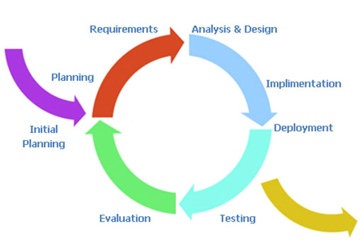

**Figure 1 Software Development Life Cycle : "Iterative Model"**

Our project uses iterative development process to develop the software, which is a development approach that "cycles" through the development phases, from gathering requirements to delivering functionality in a working release. When the process flows into iterative, the process will start from the first step then go to the next step till the last. After that, the process will back to the first step and start again. The iteration will be repeated until all processes planned are complete then out from the loop and go to next main phase.

**Iterative all features**: This phase is about the separate system into many features, and then iterative create all feature from the first feature till the final feature. For

this phase, it will be divided into 6 phases. There are:

- **Plan**: Planning the method for creating and test each feature.

- **Implement**: Implementing and coding each feature.

- **Test**: Testing and fixing each feature.

- **Review:** Reviewing and maintaining each feature to meet the feature plan.

- **System test phase**: This phase will integrate all features into one system and then create test document from system testing.

- **Deploy phase:** This phase is about deploying the whole system to the server and use as a regular mobile application and web application.

### **2.2 Software Acquisition Plans**

#### **2.2.1 Design Tools**

- Draw.io

- Visual Paradigm

**2.2.2 Development Tools**

- Force.com

**2.2.3 Configuration Management Tools**

- Google Drive

**2.2.4 Document Tools**

- Microsoft Word

- Microsoft PowerPoint

**2.2.5 Operating System**

- Microsoft Windows

- macOS

# **CHAPTER THREE | Management Procedures**

## **3.1 Project Team Structure**

|  |  |
| --- | --- |
| **Participants** | **Activities** |
| **Mr. Dolawat Wannapira**  **Mr. Suradis Sutampang** | Feasibility Study |
| Project Proposal |
| Project Requirements |
| Project Plan |
| Project Design |
| Implementation |
| Testing |

## **3.2 Monitoring and Controlling Mechanisms**

### **3.2.1 Project Meeting**

|  |  |
| --- | --- |
| **Participants** | **Roles** |
| **Mr. Dolawat Wannapira** | Development team member |
| **Mr. Suradis Sutampang** | Development team member |
| **Dr. Chartchai Doungsa-ard** | Project advisor |

# **CHAPTER FOUR | Quality Standard**

## **4.1 ISO 29110 for Very Small Entity (VSE)**

ISO29110 is a guide applies to a Very Small Entity (VSE), enterprise, organization, department or project up to 25 people, dedicated to software development. The Guide provides Project Management and Software Implementation processes, which integrate practices based on the selection of ISO/IEC 12207- Systems and Software Engineering —Software Life Cycle Processes and ISO/IEC 15289 Software Engineering – Software Life Cycle Process – guidelines for the content of software life cycle process information products (documentation) standards elements.

**4.1.1 Project Management (PM) process**

**Purpose**

The purpose of the Project Management process is to establish and carry out in a systematic way the tasks of the software implementation project, which allows complying with the project’s objectives in the expected quality, time and costs.

**Objectives**

**PM. O1.** The Project Plan for the execution of the project is developed according to the Statement of Workand validated with the Customer. The tasks and resources necessary to complete the work are sized and estimated.

**PM. O1. Tasks in this project:**

1. Create a Project Plan related with the Project Proposal.

**PM. O2.** The progress of the project is monitored against the Project Planand recorded in the Progress Status Record. Corrections to remediate problems and deviations from the plan are taken when project targets are not achieved. Appropriate treatment is taken to correct or avoid the impact of risk. Closure of the project is performed to get the Customer acceptance documented in the *Acceptance Record*.

**PM. O2. Tasks in this project:**

1. Record the project status in Project Status Record for each progress.

2. Establish the Acceptance Record before submitting final progress.

**PM. O3.** The Change Requests are addressed through their reception and analysis. Changes to software requirements are evaluated for cost, schedule, and technical impact.

**PM. O3. Tasks in this project:**

1. Analyzing the change.

2. Setting the change request form.

3. Approving the change request by project advisor.

4. Change the project follows by approved change request.

**PM. O4.** Review meetings with the Work Team and the Customer are held. Agreements are registered and tracked.

**PM. O4. Tasks in this project:**

1. Meeting with team members and project advisor.

2. Evaluate meeting results.

**PM. O5.** Risks are identified as they develop and during the conduct of the project.

**PM. O5. Tasks in this project:**

1. Identify the risks.

2. Analyze the risks.

3. Plan for managing the risks in the Project Plan.

**PM. O6.** A Software Version Control Strategy is developed. Items of Software Configuration are identified, defined and baselined. Modifications and releases of the items are controlled and made available to the Customer and Work Team including the storage, handling, and delivery of the items.

**PM. O6. Tasks in this project:**

1. Set rule for manage the version control.

2. Identify time for update version control.

3. Record the change of each version in the version control table.

**PM. O7.** Software Quality Assurance is performed to provide assurance that work products and processes comply with the Project Plan and Requirements Specification.

**PM. O7. Tasks in this project:**

1. Create tasks follow ISO29110 for VSE to the Project Plan and Requirements Specification.

### 

### **4.1.2 Software Implementation (SI) process**

**Purpose**

The purpose of the Software Implementation process is the systematic performance of the analysis, design, construction, integration and tests activities for new or modified software products according to the specified requirements.

**Objectives**

**SI. O1.** Tasks of the activities are performed through the accomplishment of the current Project Plan.

**SI. O1. Tasks in this project:**

1. Develop software complies with the current Project Plan.

**SI. O2.** Software requirements are defined, analyzed for correctness and testability, approved by the Customer, base lined and communicated.

**SI. O2. Tasks in this project:**

1. Analyze the requirements.

2. Accomplish the Software Requirements Specification.

**SI. O3.** Software architectural and detailed design is developed and base lined. It describes the software items and internal and external interfaces of them. Consistency and traceability to software requirements are established.

**SI. O3. Tasks in this project:**

1. Create Software Design Document that covers all of the Software Requirements.

2. Create Traceability Record to trace the items in Software Design Document with the software requirements.

**SI. O4.** Software components defined by the design are produced. A unit test is defined and performed to verify the consistency with requirements and the design. Traceability to the requirements and design are established.

**SI. O4. Tasks in this project:**

1. Create a Unit test that complies with requirements and design after software components are produced.

2. Perform the unit test.

3. Traceability record is created for tracing Unit test with the requirements and design.

**SI. O5.** The software is produced performing integration of software components and verified using Test Cases and Test Procedures. Results are recorded in the Test Report. Defects are corrected and consistency and traceability to Software Design are established.

**SI. O5. Tasks in this project:**

1. Design Test Cases from Software Design.

2. Test the software components.

3. Record the Test Cases results at the Test Report.

4. Create traceability record.

**SI. O6.** A Software Configuration, that meets the Requirements Specification as agreed to with the Customer, which includes user, operation and maintenance documentations is integrated, base lined and stored at the Project Repository. Needs for changes to the Software Configuration are detected and related Change Requests are initiated.

**SI. O6. Tasks in this project:**

1. Create the change request form.

2. Approve the change request by project advisor.

3. Change the project complies with approved change request.

**SI. O7.** Verification and Validation tasks of all required work products are performed using the defined criteria to achieve consistency among output and input products in each activity. Defects are identified, and corrected; records are stored in the Verification/Validation Results.

**SI. O7. Tasks in this project:**

1. All works are traceable and have tested.

# **CHAPTER FIVE | Schedule and Milestones**

## **5.1 Schedule**

| Milestone | Task | Milestone Criteria | Planned date |
| --- | --- | --- | --- |
| 1 | Proposal | Topic defined | May 2017 |
| 2 | Proposal | - Proposal reviewed  - Proposal submitted  - Proposal presentation | June 2017 |
| 3 | Progress  Report I | - Software requirements specification  - Feature#1 (Child’s development information management.)  - Feature design  - Test plan  - Feature implement  - Feature test  - Progress report submit  - Progress report presentation | July – August 2017 |
| 4 | Progress  Report II | - Feature#2 (Child's education information management.)  -Feature#3 (Report development information.)  - Feature design  - Test plan  - Feature implement  - Feature test  - Progress report submit  - Progress report presentation | September - October 2017 |
| 5 | Show Pro | - Feature#4 (Child’s information forwarding.)  - Feature design  - Test plan  - Feature implement  - Feature test  - Progress report submit  - Progress report presentation | November 2017 |
| 6 | Final Progress  Report | - Overall system must be complete  -Integrate and review all documents  - Tests all features  - Reviews documents are complete.  - Progress report submit  - Progress report presentation | December 2017 |

## **5.2 Milestone**

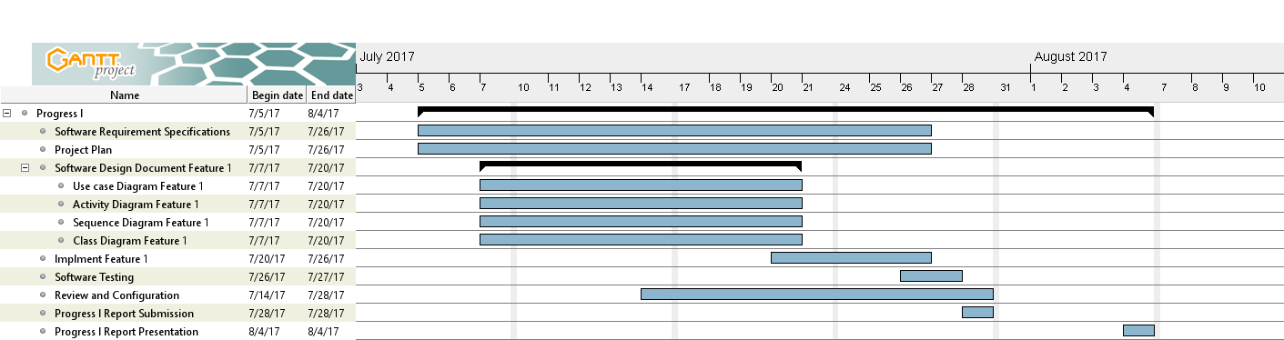

**Figure 2 Progress I Milestone**

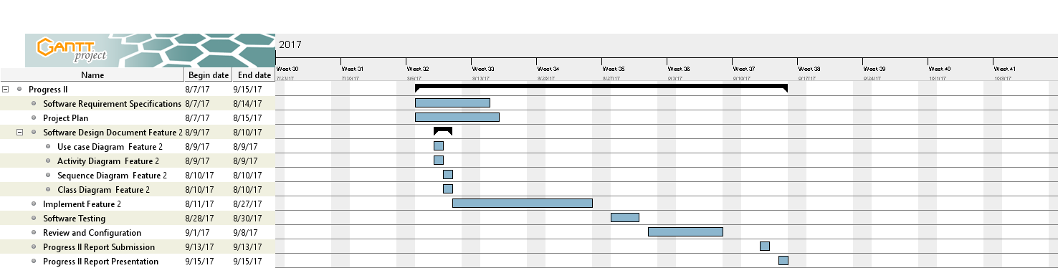

**Figure 3 Progress II Milestone**

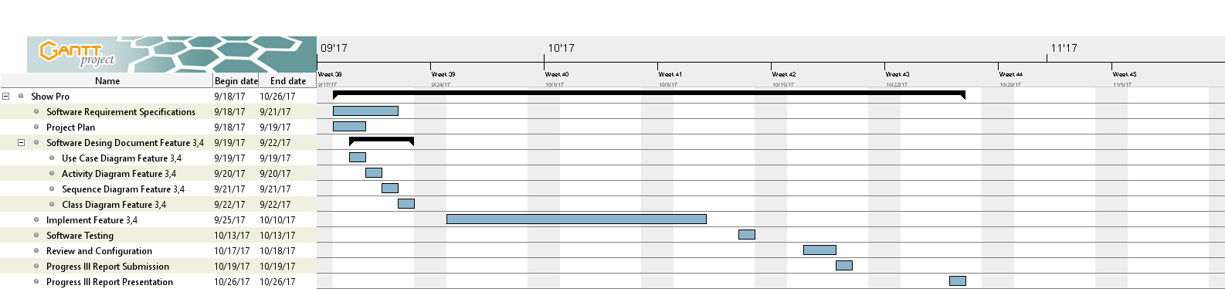

**Figure 4 Show Pro Progress Milestone**

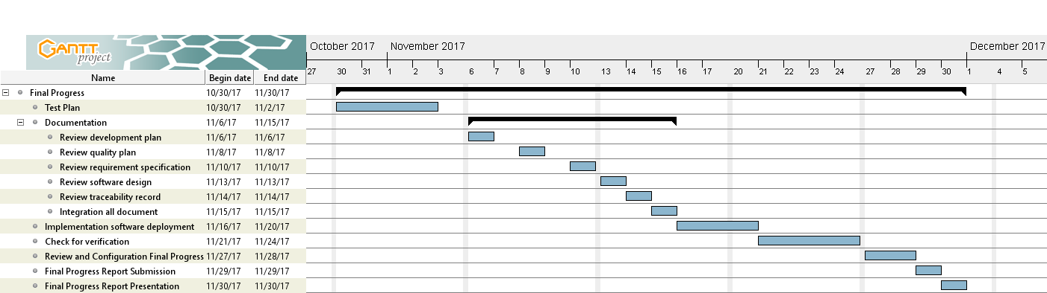

**Figure 5 Final Progress Milestone**

# **CHAPTER SIX | Software Configuration**

## **6.1 Software Configuration Management**

Software Configuration Management is a set of activities designed to control change by identifying the work products that are likely to change, establishing relationships among them, defining mechanisms for managing different versions of these work products, controlling the changes imposed, and auditing and reporting on the changes made. In other words, SCM is a methodology to control and manage software development project and in this project, we use version control to manage to report on the changes made.

## **6.2 Filename Format**

For the filename format that we using for all project documents is:[Document name] _[Version]. file type

**- Document Name**

This part will depend on the substance of that file. In each file, will has its certain name as following:

Proposal

Project Plan

Software Requirement Specification (SRS)

Software Design Document (SDD)

Test Plan

Test Record

Traceability Record(TR)

**- Version**

This part is the version of the document. The version number will be in the following format: “V. [Main version]. [Sub version]”

* The main version is the main of version software and document. For example, V.3.0, the number 3 is the main version. It might refer to a feature of the software.
* Subversion is a part of main for developing. Subversion will have updated more than the main version.

**- File Type**

This part is the type of file or the file extension. For example,.docx,.pdf.

## **6.3 Change Management**

Change management manages all of the changes in the project during the development process. All the change requests will be record into the change request document.

We have the strategy for manage the changes by following these steps:

1. Analyzing the change.

2. Setting the change request form.

3. Approving the change request by project advisor.

4. Change the project follows by approved change request.

## **6.4 Project Repository**

We use “Google Drive” to helps to manage the version of document. So, the developers can share file, update or revision.

# **CHAPTER SEVEN | Risk Management**

Risk management is concerned with identifying risks and drawing up plans to minimize their effect on the project. A risk is a probability that some adverse circumstance will occur.

- Project risks affect schedule or resources.

- Product risks affect the quality or performance of the software being developed.

- Business risks affect the project team while developing or procuring the software.

Identified risks at the start of the project and the start of the development phase. All identified risks are documented and assessed in the Risk Management Process by the Project Team. In the Risk Management Process defines the possible risks and solution of them, and who is responsible for.

## **7.1 Risk Management Process**

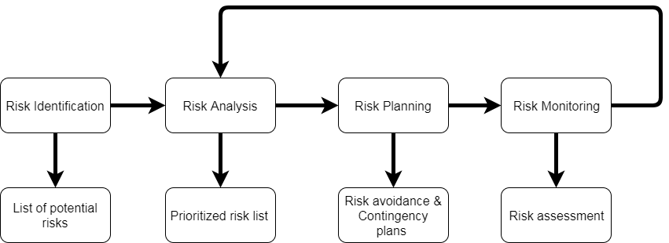

**Figure 6 Risk Management Process**

1. Risk identification: identify project, product and business risks.

2. Risk analysis: Assess the likelihood and consequences of the risks.

3. Risk planning: Draw up plans to avoid or minimize the effects of the risks.

4. Risk monitoring: Monitor the risks throughout the project.

## 

## 

## **7.2 Risk Identification and Solutions**

| No. | Risk Statement | Risk Solution | Priority |
| --- | --- | --- | --- |
| 1 | The requirements might be changed. | - Meeting and discuss the impact of the changed requirements with the user, team member and project advisor.  - Design system which changed requirements and related with the other requirements.  - Use software configuration management and follow change management step. | High |
| 2 | Team member maybe get engaged and can’t develop the project. | - Assign work to left team member who doesn’t get involved. | Low |
| 3 | Work products are not submitted on time. | - Establish the project plan.  - Develop project follow the project plan. | High |
| 4 | Work products are not traceable. | - Create the traceability record. | Medium |
| 5 | Team member lack skill and knowledge. | - Team member is tutoring implementation.  - Ask for assistance and support from textbooks, websites, an experienced developer, and advisor. | High |
| 6 | Ambiguous responsibility. | - Always discuss the work together. | Medium |
| 7 | Team member misunderstands system work. | - The member’s review system before development phase and use diagram to explain system working. | High |
| 8 | Human resource not enough. | - Planning schedule and hard working. | Medium |
| 9 | Unfamiliar with a testing process. | - Studying test technique during the test design. | Medium |
| 10 | Bad communication between team members | - Try to understand each other and exchange more information together. | Medium |